# Abstract

Intonation, pitch modulation across an utterance, plays a critical role in communication, signaling sentence type, speaker intent, pragmatic nuances, and other functions. Second language (L2) learners often struggle to interpret intonation in a target-like fashion, particularly in unfamiliar dialects, which can impact comprehension and communicative success. Emerging evidence suggests that individual differences in empathy, the ability to infer others’ intentions and emotions, influences L2 intonation acquisition. The present study investigated whether native English L2 Spanish learners with higher empathy more effectively acquire a novel intonation contour from Puerto Rican and Cuban Spanish: absolute interrogatives with low boundary tones. 200 learners of varying proficiency completed a two-alternative forced choice task judging whether utterances were questions or statements. Half of the participants received a brief incidental-learning training session (<5 minutes) consisting of naturalistic conversations with a content-based question after each. Bayesian multilevel regression revealed that response accuracy positively correlated with proficiency in both groups. Critically, in the trained group, this effect was modulated by empathy: higher-empathy learners with above-average proficiency performed better than lower-empathy peers. These results suggest that empathy facilitates L2 intonation acquisition by helping learners store more socially and linguistically relevant information, supporting faster establishment of novel sound-to-meaning associations.

*Keywords*: empathy; intonation; second language acquisition; speech perception; incidental learning

# Rapid Acquisition of a Novel Intonation Contour by High-Empathy L2 Learners

Most second language acquisition (SLA) phonological models focus primarily on segmental features, while suprasegmental features receive comparatively little theoretical or pedagogical attention. Intonation, the modulation of pitch across an utterance, is one such understudied feature (Jenkins, 2004; Rao, 2019), despite its critical role in communication. It can signal sentence type (Prieto & Roseano, 2010), speaker commitment (Orrico et al., 2020), or politeness (Devı́s Herraiz & Cantero Serena, 2014), among many other diverse functions. Given the many-to-many mappings between sound and meaning, second language (L2) learners often struggle with intonation, in part due to transfer effects from their first language (Mennen, 2015; Trofimovich & Baker, 2006). However, not all learners are equally affected. Emerging evidence indicates that target-like perception of intonation is influenced by pragmatic skills, particularly empathy (Casillas et al., 2023). This aligns with findings in monolingual (L1) populations, where higher empathy is associated with increased sensitivity to intonational contours (Esteve-Gibert et al., 2016, 2020; Orrico et al., 2025; Orrico & D’imperio, 2020).

The present study contributes to these lines of research by investigating the causal link between empathy and intonation in L2 populations. I examined a situation common to L2 learners: exposure to an unfamiliar dialect and the task of accurately interpreting its intonational patterns. Specifically, participants judged whether an utterance was a question or a statement. Based on prior findings that higher-emapthy learners encode more information during communicative interactions (Melchers et al., 2017), it was hypothesized that they would more rapidly acquire the novel sound-to-meaning mapping and outperform their lower-empathy peers in a two-alternative forced choice task after a very brief incidental-learning (Hulstijn, 2003) training session.

# 1. Background and Motivation

## *1.1 L2 Intonation Acquisition*

Investigation in first language (L1) intonational phonology has exploded since the groundbreaking work by Ladd (2008) and colleagues (Pierrehumbert, 1980), but research on intonation SLA has lagged behind. L2 learners face challenges acquiring the target language’s intonation system (Trofimovich & Baker, 2006), and these difficulties may result in comprehension issues and communication breakdowns. Intonation serves to signal various and distinct communicative functions across syntax, pragmatics, and semantics, such as constituent focusing (Büring, 2016), affective meaning (Rodero, 2011), and politeness (Herrero et al., 2020). In Spanish, one such function is sentence modality (Navarro Tomás et al., 1974). For example, the spoken utterance ‘Mariano habla del tiempo’ *Mariano talks about the weather* may variably be a declarative or interrogative depending on the intonational contour. Given the many challenges posed to an L2 learner, a central question that remains is how existing SLA models can be used to account for the acquisition of intonation.

Current SLA models, such as Speech Learning Model (SLM) revised (Flege & Bohn, 2021), primarily focus on segmental phonology. The L2 Intonation Learning Theory (LILt, Mennen, 2015) serves as step into SLA suprasegmental phonology as a working production model. Similar to the SLM-r, the LILt model proposes that intonation acquisition outcomes depend on cross-language similarities and differences on one or more of four dimensions (systemic, realizational, semantic, and frequency). The LILt model predicts that L2 learners whose target language converges on one or more dimensions between their L1 and L2 exhibit positive transfer, whereas differences in dimensions negative transfer.

A ripe area for investigating L1-L2 intonation transfer is L1 English L2 Spanish perception of Spanish absolute interrogatives (i.e., yes-no questions) cued by a low boundary tone, such as those found in Caribbean (Armstrong, 2010; Bailey, 2014; Willis, 2010) and Galician Spanish (Pérez Castillejo & Fuente Iglesias, 2024), as well as some other varieties (Astruc et al., 2010; Gabriel et al., 2010). According to the LILt model, L1 English L2 Spanish learners are predicted to have difficulty accurately processing these utterances, specifically because the sound-to-meaning relationship differs between English and Spanish on the *semantic* dimension. What little data is available has demonstrated that L1 English L2 Spanish speakers face difficulty interpreting these utterances accurately as interrogatives (Brandl et al., 2020; Casillas et al., 2023; George, 2024). However, there has been little research directly investigating the acquisition of a low boundary tone to signal absolute interrogatives in L2 Spanish learners (Trimble, 2013b; for contrary results, see Bedialauneta Txurruka, 2023), possibly due to variety biases in pedagogical material (Gallego & Conley, 2013).

Trimble (2013b), for example, investigated the intonational development of L1 English L2 Spanish speakers in a partial replication of Face (2007). Participants of varying proficiency levels (beginner, advanced) and study abroad experiences (Toledo, Spain; Mérida, Venezuela) completed a two-alternative forced choice task in which they categorized broad focus declaratives and absolute interrogatives as questions or not. The stimuli were produced by speakers from two varieties that signal absolute interrogatives with a final rise (Toledo, Spain; L2, United States), and one variety with a final fall (Mérida, Venezuela). Ceiling performance was found for all dialect utterance types except for Venezuelan absolute interrogatives, the response accuracy of which depended on proficiency and study abroad experience. However, even advanced learners with study abroad experience in Mérida, Venezuela did not perform at ceiling.

In a similar two-alternative forced choice task, Casillas et al. (2023) presented participants across a wide range of proficiency levels with four utterance types (broad focus declarative, narrow focus declarative, wh- question, absolute interrogative) across eight varieties of Spanish, two of which were Puerto Rican and Cuban. The absolute interrogative utterances from these varieties featured the expected low boundary tone. Although no analysis was done specifically on Caribbean absolute interrogatives, the Caribbean varieties had the lowest response accuracy across all proficiency levels.

Based on the available research, L2 intonation perception is positively correlated with target language proficiency. Furthermore, the reviewed studies, on the whole, support predictions from the LILt model that L1 English L2 Spanish learners have difficulties accurately interpreting absolute interrogatives with low boundary tones, such as those in Caribbean varieties. Given that L2 learners struggle overall with these tasks, the results provide important implications for L2 pedagogy.

## *1.2 L2 Intonation in the Language Classroom*

Despite the various systematic functions of intonation, it remains sidelined in the L2 classroom (Jenkins, 2004; Rao, 2019). As with other linguistic areas, intonation transfer effects, as predicted by the LILt model (Mennen, 2015) may impose meaningful communication issues for L2 learners, motivating its inclusion in pedagogical material. Herrero and Devı́s (2020), for example, investigated L1 Mandarin Chinese L2 Spanish learners’ production of polite requests in Spanish evaluated by L1 Spanish speakers. They found that even if the utterance by the L2 learners included lexical-grammatical aggression mitigators (such as ‘gracias’ *please*), L1 Spanish speakers relied primarily on intonation to evaluate the utterance’s politeness. In a similar vein, Estebas-Vilaplana (2014) investigated intonational differences between English and Spanish responses to wh- questions as perceived by L1 speakers of English and Spanish. Participants were instructed to evaluate each utterance as “expected” (i.e., natural, polite, or nice) or “unexpected” (rude, impolite, or over-excited). She found that the expected pitch ranges in English and Spanish are at an opposition: broad pitch range is polite in English, but over-excited in Spanish; narrow pitch range is rude in English, but polite in Spanish. These studies work to highlight the importance of intonation in the L2 classroom, but it remains unclear how intonation should be included.

Research evaluating intonation-teaching methodologies remain limited. Recent research has demonstrated that intentional (Hulstijn, 2003) training methodologies (e.g., instructional sound-to-meaning mapping, shadowing exercises) resulted in meaningful improvement in L2 perception and production (Olea, 2019; Sonsaat-Hegelheimer & Levis, 2025). For example, Sonsaat-Hegelheimer and Levis (2025) examined student gains after a three-week training on final intonation contours (fall, rise, fall-rise) in L1 Turkish L2 English learners. It was predicted that participants would have most issue with rises and fall-rises due to Turkish having a more constrained inventory of boundary tones than Germanic languages (Kabak, 2016). These predictions were borne out in the pre-test. In the post-test, participants displayed meaningful improvements in both the perception and production of these problem final contours, indicating that with this training, cross-linguistic influence may be inhibited.

George et al. (2019), on the other hand, completed a 30-minute training session with intermediate to advanced L1 English L2 Spanish learners. The instructor focused on three utterance types (declaratives, absolute interrogatives, and wh- questions) in eight dialects, presenting audios and pitch tracks from the Interactive Atlas of Spanish Intonation (Prieto & Roseano, 2009--2013). She highlighted differences in the overall contour, pitch accents, and boundary tones. Participants completed a pre- and post-test discourse completion task to elicit each sentence type. George et al. (2019) compared the pre- and post-test solely on differences and found that the training had no impact on declarative production, and only some impact on absolute interrogative and wh- question production.

The above studies used training methodologies that relied on intentional learning paradigms. However, these studies represent a very small minority of what most L2 learners experience when acquiring intonation. As intonation is not typically explicitly or intentionally taught in the classroom, learners most likely rely on L1-L2 transfer (Ortega-Llebaria & Colantoni, 2014) or incidental learning through input from the instructor or other input. Incidental learning in the current investigation is based on a definition provided by Hulstijn (2003): “the ‘picking up’ of words and structures, simply by engaging in a variety of communicative activities… during which the learner’s attention is focused on the meaning rather than on the form of language” (p. 1). The majority of research on intentional and incidental learning has focused primarily on vocabulary (and spelling), and secondarily on morphology and syntax. Phonetics and phonology, on the other hand, has not received attention where the research goal makes clear a distinction between intentional and incidental learning. As such, an important theoretical consideration is *how* L2 learners acquire intonation in their target language without explicit instruction and what factors there are to consider in their development. One way to address this gap is by considering learner-internal variables that may shape how intonation is acquired under these circumstances.

## *1.3 Individual Differences in Empathy*

Individual pragmatic differences in learners in regards to L2 intonational phonology acquisition has received garnered greater attention in recent years (Bishop, 2016; Bishop et al., 2015; Diehl et al., 2008; Ward & Hirschberg, 1988). The construct empathy has also received greater attention. Empathy, one’s ability to infer others’ intentions (Baron-Cohen & Wheelwright, 2004), has been associated with theory of mind, mindreading, mentalizing, and perspective-taking (Baron-Cohen, 2011; Carruthers, 2009; Frith & Frith, 2003). Typically, empathy is categorized by *affective empathy*, or emotional alignment with the interlocutor, and *cognitive empathy*, recognizing and understanding what an interlocutor feels or thinks. The latter categorization has clear ties to the linguistic domain: empathy is necessary to comprehend an interlocutor’s motives in verbal interactions, especially for the interpretation of non-literal meaning.

A growing body of research has provided evidence that the empathy explains some variability in L1 intonation perception (Esteve-Gibert et al., 2016, 2020; Orrico et al., 2025; Orrico & D’imperio, 2020), and preliminary evidence in the L2. For example, Casillas et al. (2023) found an interaction between proficiency and empathy score in L1 English L2 Spanish learners, such that lower-proficiency learners with higher empathy scores, measured with the Empathy Quotient (Baron-Cohen & Wheelwright, 2004), performed more accurately when identifying an utterance as a question or not. Apart from this one example, there has been no modern SLA research relating empathy to L2 perceptual development.

Although the link between empathy and intonation processing has been established in L1 and L2 research, the causal relationship has not been thoroughly or explicitly investigated. One possibility is that L2 learners with higher empathy store more information about the linguistic content, even if it is not the focus of a given communicative activity. For example, Melchers et al. (2017) found that higher-empathy participants more accurately responded to content-based questions about brief videos than their lower-empathy peers. These findings suggest a possible mechanism: learners with higher empathy may encode and retain more information during communicative activities, even when attention is focused on meaning rather than form. However, this hypothesis has not been directly tested in L2 intonation acquisition.

# 2. Present Study

The present study investigates whether L1 English L2 Spanish learners can rapidly acquire accurate perception of Spanish absolute interrogatives with low boundary tones, a feature characteristic of Puerto Rican and Cuban varieties and predicted by the LILt model to be difficult for L1 English speakers (Mennen, 2015). Specifically, I investigate the relationship between acquisition of the target sound-meaning relationship and the construct empathy (Baron-Cohen & Wheelwright, 2004). Although previous research has established a relationship between empathy and intonation in L1 speakers (Esteve-Gibert et al., 2016, 2020; Orrico et al., 2025; Orrico & D’imperio, 2020) and L2 learners (Casillas et al., 2023), it is remains unclear why individuals with differing empathy perform differently. This study was preregistered on the Open Science Framework (https://osf.io/p6vuz) and designed to address the following research questions:

1. Do higher-empathy L1 English L2 Spanish speakers make greater use of prosodic cues to determine if a Spanish utterance is an interrogative?
2. Do higher-empathy L1 English L2 Spanish speakers make greater use of prosodic input from dialects to which they have little or no exposure to extract prosodic features?

With respect to RQ1, it is expected that higher-empathy learners, compared to lower-empathy learners, will more accurately identify sentence type, in line with Casillas et al. (2023).

As for RQ2, it is predicted that higher-empathy individuals will benefit greater from a brief incidental-learning training session, and perform more accurately than their lower-empathy peers when categorizing absolute interrogative utterances with low boundary tones. Specifically, I believe this is because the higher-empathy individuals store more information about the form and function of the low boundary tone during the incidental training session, which inhibits L1-L2 transfer.

# 3. Methodology

## *3.1 Participants*

Two experiments were launched on the online experimental platform Prolific.ac: one for the experimental group and one for the control group. Upon beginning either experiment, all participants responded to the question “Are you familiar with Caribbean (e.g., Caribbean, Puerto Rican) or Galician Spanish?”, which served as a proxy for if the individual was familiar with a variety that signals absolute interrogatives with a final fall. Participants chose from a drop-down menu either “yes” or “no”. Participants were recruited until both groups had 100 participants each that responded “no”.

The pool of participants for both groups were filtered primarily by using criteria set in Prolific.ac. Participants self-reported as being adult L1 English speakers born, raised, and currently living in the Northeastern US. Furthermore, participants reported growing up as a monolingual English speaker. They reported no hearing difficulties and were required to use headphones on a personal computer.

To address RQ1, all recruited participants in the control group were included in the analysis (n = 140). For RQ2, only the first 100 participants from each group who responded that they were unfamiliar with the above-specified dialects were included.

Both groups were compensated at a rate of $12.00 per hour. Upon completing all tasks, control group participants were paid $3.00, while experimental group participants $4.00. The control group’s median completion time was approximately 14, while the experimental group’s was approximately 16.

## *3.2 Tasks*

The experimental and control groups performed the same tasks: a 2AFC task, a lexical decision vocabulary assessment, and a Likert-type questionnaire to assess empathy. The experimental group completed an additional “exposure” task first. The tasks were programed in Python using PsychoPy3 (Peirce et al., 2019) and hosted on Pavlovia. All code and material used to generate the tasks are freely available on the Open Science Framework.

### 3.2.1 Exposure Stimuli

Participants in the experimental group were first exposed to three naturalistic phone conversations. Each conversation was between two speakers of either Dominican, Puerto Rican, or Galician Spanish talking about everyday topics. These varieties were chosen because absolute interrogatives are signaled by a final fall. Table 1 documents the total number of absolute interrogatives produced in each conversation and the count of absolute interrogatives that featured a final fall.

Table 1. Stimuli for exposure trials in experimental group.

| variety | time (seconds) | # of absolute interrogatives | # of absolute interrogatives with final fall |
| --- | --- | --- | --- |
| Dominican | 60 | 10 | 7 |
| Galician | 47 | 5 | 3 |
| Puerto Rican | 36 | 6 | 6 |
| TOTAL | 143 | 21 | 16 |

### 

### 3.2.2 2AFC

The auditory stimuli for the two-alternative forced choice task (2AFC) consisted of 88 items total, a subset of those used in Casillas et al. (2023), specifically from Cuban, Puerto Rican, Mexican, and Castilian speakers. Each speaker produced the same 22 utterances, evenly split between broad focus and absolute interrogative utterances. The sentences were made up of three function words following a subject-verb-object (SVO) word order, the default in Spanish. The object was a noun with penultimate stress. A detailed description of the auditory stimuli is provided in the OSF repository from Casillas et al. (2023) at: <https://osf.io/zxkdt>.

### 3.2.3 LexTALE

Spanish proficiency was assessed by administering the Lexical Test for Advanced Learners of Spanish (LexTALE-ESP, henceforth LexTALE, Izura et al., 2014; Lemhöfer & Broersma, 2012). The LexTALE is a lexical decision experiment that provides a standardized assessment of vocabulary size in Spanish. Participants are exposed to a series of real words and pseudowords on the computer screen, and they must decide if the word is real or fake. Proficiency in this study is treated as a continuous variable.

To assess how participants performed on this measure, descriptive statistics and a regression model were computed. Table 2 shows the descriptive statistics of LexTALE scores from the participant samples used to address RQ1 and RQ2. A Bayesian regression model was fit to LexTALE score as a function of *group*. The intercept estimate was β = 0.33 (HDI = [-1.37, 2.07]). Relative to the baseline, the experimental group was estimated to score slightly higher (β = -0.05, HDI = [-2.50, 2.34]), but this is not interpreted as a meaningful difference.

Table 2. Descriptive statistics of LexTALE scores.

| Dataset | Mean | SD | Min | Max |
| --- | --- | --- | --- | --- |
| RQ1 | 0.35 | 8.91 | -17 | 41 |
| RQ2 (control) | 0.36 | 8.07 | -16 | 31 |
| RQ2 (experimental) | 0.28 | 10.14 | -26 | 55 |

### 

### 3.2.4 Empathy Questionnaire

The construct empathy was assessed using the Empathy Quotient (EQ, Baron-Cohen & Wheelwright, 2004). The EQ consists of 60 items, 40 critical items and 20 distractors, that are evaluated using a four-point Likert scale ranging from “strongly agree” to “strongly disagree”. To avoid response bias, choices indicating empathic responses are coded to elicit “agree” responses in half the target items and “disagree” responses in the other half. The target items are scored with 2 or 1 points based on if the participant responds “strongly” or “slightly” to the “empathic” response, and 0 if the participants responds with the “non-empathic” response. The EQ is scored by summing the total points to produce a single value indicating an individual’s level of empathy. Scores range from 0 (low empathy) to 80 (high empathy).

To assess how participants performed on this measure, descriptive statistics and a regression model were computed. Table 3 shows the descriptive statistics of EQ scores from the participant samples used to address RQ1 and RQ2. A Bayesian regression model was fit to EQ score as a function of *group*. The intercept estimate was β = 39.45 (HDI = [37.08, 41.73]). Relative to the baseline, the experimental group was estimated to score slightly higher (β = 2.06, HDI = [-1.14, 5.34]), but this is not interpreted as a meaningful difference.

Table 3. Descriptive statistics of EQ scores.

| Dataset | Mean | SD | Min | Max |
| --- | --- | --- | --- | --- |
| RQ1 | 42.09 | 11.93 | 15 | 74 |
| RQ2 (control) | 41.74 | 12.08 | 15 | 74 |
| RQ2 (experimental) | 41.63 | 12.43 | 12 | 67 |

## 

## *3.3 Procedure*

Participants were recruited on Prolific.ac and completed all tasks in a single session. The experimental group first completed the “exposure” task. After each conversation, participants responded to a true-or-false question regarding the contents of the conversation.

Both groups then completed the same 2AFC task. Participants were presented an audio file that was either a broad-focus declarative or absolute interrogative. Participants were instructed to determine as quickly and accurately as possible if the utterance they heard was a question. At the start of each audio, they were prompted on-screen with the question, “Is this a question?” and they responded with their keyboard by typing either “1” for “yes” or “0” for “no”. Afterwards, participants completed the LexTALE and Empathy Quotient.

## *3.4 Statistical Analysis*

I report two statistical analyses. Both analyses model response accuracy using Bayesian multilevel logistic regression. Both models’ likelihoods were Bernoulli distributed with logit link functions. All continuous variables were standardized. The criterion, *response*, was coded as “1” for correct responses and “0” for incorrect responses. That is, the models represented the probability of accurately responding to the prompt, “Is this a question?”.

The first analysis addressing RQ1 considered response accuracy for the population effects *caribbean* (‘0’ for Castilian and Mexican dialects; ‘1’ for Cuban and Puerto Rican dialects), *utterance type* (broad focus declarative and absolute interrogative), *LexTALE score*, *empathy quotient*, and the higher order interactions. I specified group-level effects for participants, speaker variety, and items. The slope for *utterance type* varied for the participant effect, as did the *LexTALE* by *EQ* interaction for the speaker variety effect. The intercept represented the log-odds response accuracy of a declarative produced by a non-Caribbean speaker at the average proficiency and EQ levels.

The second analysis addressing RQ2 considered response accuracy for the population effects *LexTALE score*, *empathy quotient*, and *group* (experimental, control), as well as the higher order interactions. I specified group-level effects for participants, speaker variety, and items. The slope for *LexTALE* by *EQ* interaction varied for the speaker variety effect. The intercept represented the control group’s log-odds response accuracy of an absolute interrogative produced by a Caribbean Spanish speaker at the average proficiency and EQ levels.

For all models, I included regularizing, weakly informative priors (Gelman et al., 2017). I sample from the posterior distribution of a given model for statistical inferences. To assess my preregistered hypotheses, I established a region of practical equivalence (ROPE) around a point null value of 0 (see Kruschke, 2018) using the following formula:

$$ROPE=\frac{μ_{1}-μ_{2}}{\sqrt{\frac{σ_{1}^{2}+σ_{2}^{2}}{2}}}$$

For all models, median posterior point estimates are reported for each parameter of interest, along with the 95% highest density interval (HDI), the percent of the region of the HDI contained within the ROPE, and the maximum probability of effect (MPE). For statistical inferences, I focus on estimation rather than decision-making rules, though, generally, a posterior distribution for a parameter in which 95% of the HDI falls outside the ROPE and a high MPE (i.e., values close to 1) are taken as compelling evidence for a given effect. I conducted all analyses using R and fit all models using the probabilistic programming language stan via the R package brms (Bürkner, 2017b, 2017a).

# 4. Results

## 

## *4.1 RQ1*

The first analysis addressed RQ1, which aimed replicate findings from Casillas et al. (2023). They found response accuracy to broad focus declaratives varied as a function of proficiency and empathy, such that low-proficiency participants with higher empathy performed more accurately than their proficiency-matched lower-empathy peers. Importantly, there was no effect found for empathy or the interaction between proficiency and EQ for absolute interrogatives.

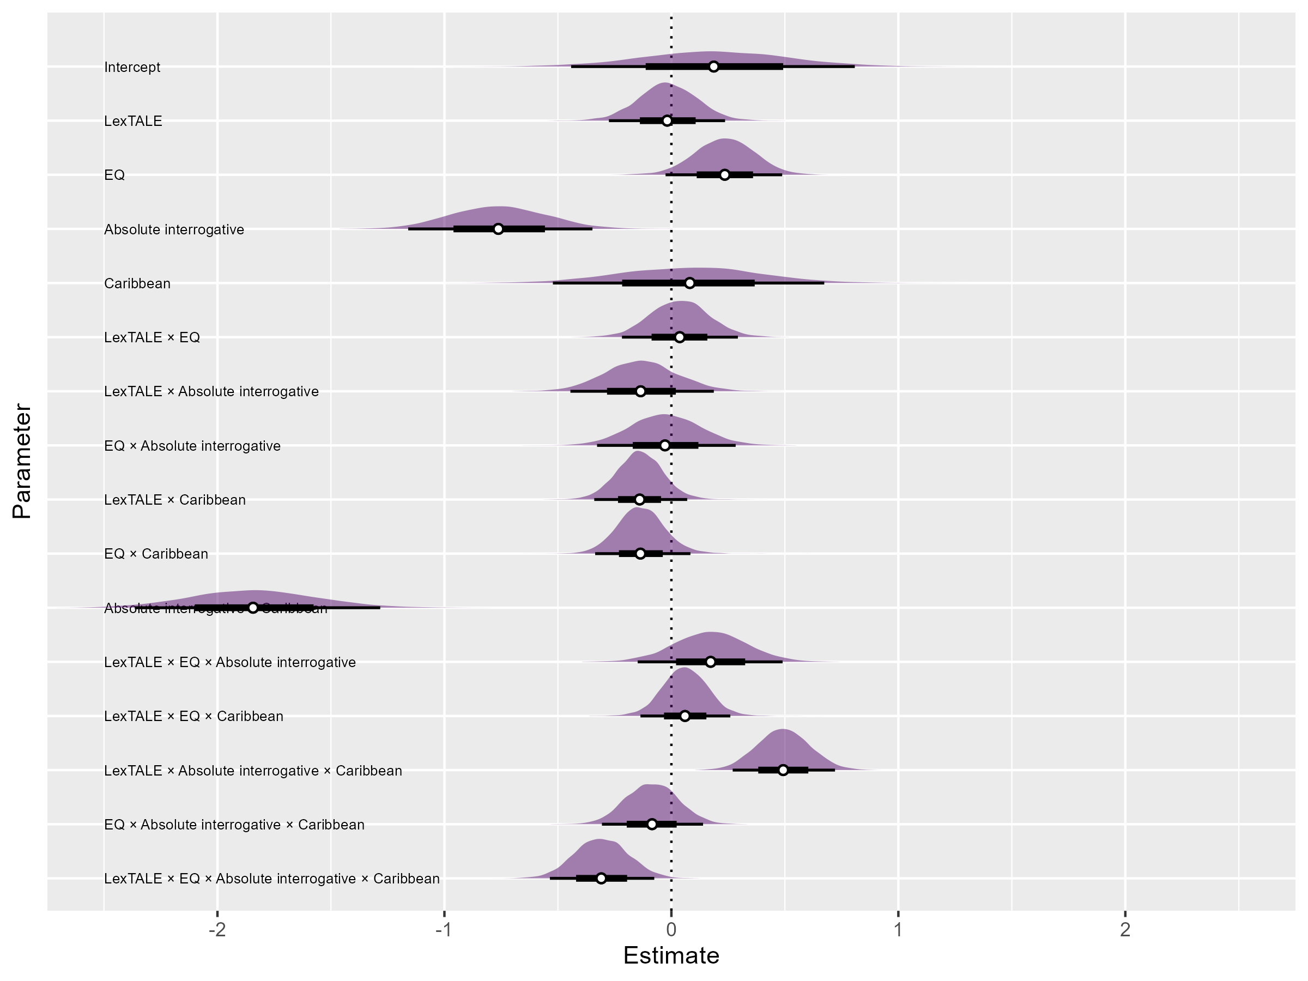

Figure 1. Forest plot summary of the omnibus model. White points represent posterior medians along with 66% and 95% highest density credible intervals.

Figure 1 is a forest plot of the model output. The log-odds of a correct response for a non-Caribbean declarative at the average proficiency and EQ levels was 0.18, or approximately 54.49%, (β = 0.18, HDI = [-0.43, 0.81], ROPE = 0.22, MPE = 0.72). Comparatively, participants performed less accurately for non-Caribbean absolute interrogatives ((β = -0.76, HDI = [-1.17, -0.34], ROPE = 0, MPE = 1)). In the case of Caribbean utterances, participants patterned similarly: declaratives ((β = 0.27, HDI = [−0.60, 1.12], ROPE = 0.16, MPE = 0.72)) were accurately identified more often than absolute interrogatives ((β = −2.34, HDI = [−3.39, −1.27], ROPE = 0.00, MPE = 1.00)). Although the median estimate for Caribbean declaratives was slightly above the median estimate of non-Caribbean declaratives, it should be noted that their HDIs largely overlap, suggesting that there is no meaningful difference between the two estimates. Caribbean absolute interrogatives, on the other hand, are on the whole more negative than non-Caribbean absolute interrogatives (β = −0.57, HDI = [−1.34, 0.20], ROPE = 0.07, MPE = 0.92), suggesting that individuals had overall more difficulty identifying Caribbean absolute interrogatives.

Figure Figure 2 plots response accuracy as a function of utterance type and proficiency (left panel) and EQ (right panel). Surprisingly, proficiency alone did not have a strong relationship with non-Caribbean declarative utterances ((β = −0.02, HDI = [−0.28, 0.24], ROPE = 0.59, MPE = 0.56)), and in fact had a negative relationship with non-Caribbean absolute interrogatives ((β = −0.15, HDI = [−0.38, 0.08], ROPE = 0.32, MPE = 0.90)) and Caribbean declaratives ((β = −0.16, HDI = [−0.44, 0.13], ROPE = 0.33, MPE = 0.86)). Caribbean absolute interrogatives, on the other hand, had a positive relationship with proficiency ((β = 0.20, HDI = [−0.01, 0.43], ROPE = 0.16, MPE = 0.97)).

Empathy, as opposed to proficiency, was a stronger predictor of response accuracy in general. Response accuracy to non-Caribbean declaratives ((β = 0.24, HDI = [−0.03, 0.49], ROPE = 0.13, MPE = 0.96)) and absolute interrogatives ((β = 0.21, HDI = [−0.02, 0.43], ROPE = 0.15, MPE = 0.96)) had largely positive posterior distributions. To a lesser extent, Caribbean declaratives had a positive relationship with empathy ((β = 0.10, HDI = [−0.18, 0.38], ROPE = 0.43, MPE = 0.77)), whereas there was little evidence to suggest a relationship between response accuracy to Caribbean absolute interrogatives and empathy ((β = −0.01, HDI = [−0.23, 0.21], ROPE = 0.68, MPE = 0.54)).

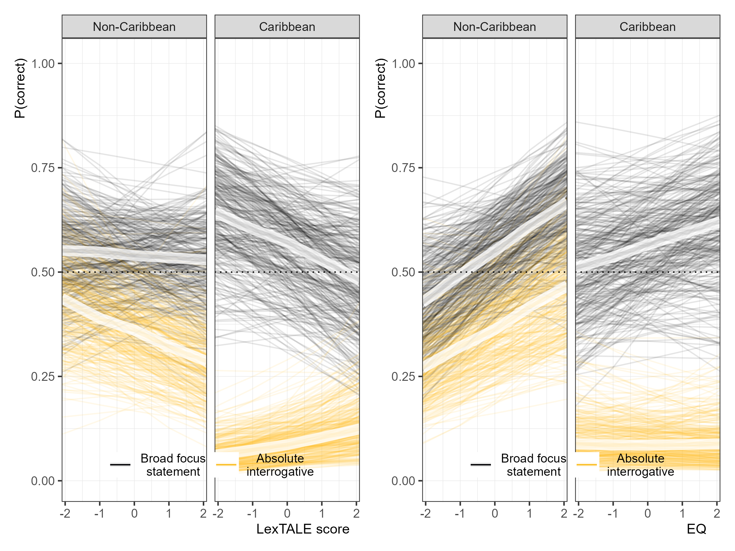

Figure 2. Conditional effects of a correct response as a function of proficiency (LexTALE score; left panel) and empathy quotient (right panel) for each combination of sentence type and Spanish variety. Thin lines represent 300 draws from the posterior distribution for each condition and illustrate uncertainty (95% HDI) around the posterior medians (thick lines).

Lastly, the model estimated the proficiency by EQ interaction for each utterance type. There was weak evidence to suggest that the proficiency effect was modulated by EQ for non-Caribbean absolute interrogatives (β = 0.21, HDI = [−0.02, 0.45], ROPE = 0.16, MPE = 0.96), but not for any other dialect or sentence type combination. Figure 3 plots the relationship. When holding standardized EQ values of -1, 0, and +1 constant for non-Caribbean absolute interrogative utterances across proficiency, the slope is more negative for lower EQ. In other words, learners with higher empathy at any given proficiency level were “protected” from the negative-going proficiency effect.

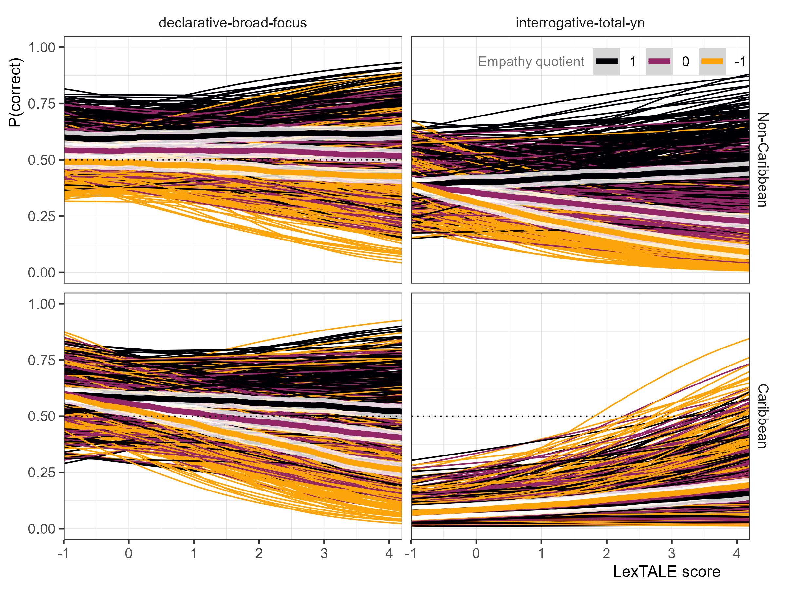

Figure 3*.* Probability of a correct response as a function of LexTALE score while holding empathy quotient scores constant at -1, 0, and +1 standard deviations from the mean. Thin lines represent 300 draws from the posterior distribution and indicate uncertainty (95% HDI) around the posterior medians (thick lines).

## 

## *4.2 RQ2*

The second analysis addressed RQ2, which asked whether L2 Spanish learners with higher empathy make greater use of prosodic cues when exposed to an unfamiliar variety of Spanish when compared to lower empathy individuals. This analysis included only Caribbean absolute interrogatives and participants who self-reported not being exposed to Caribbean or Galician varieties of Spanish (i.e., varieties with final falls for absolute interrogatives).

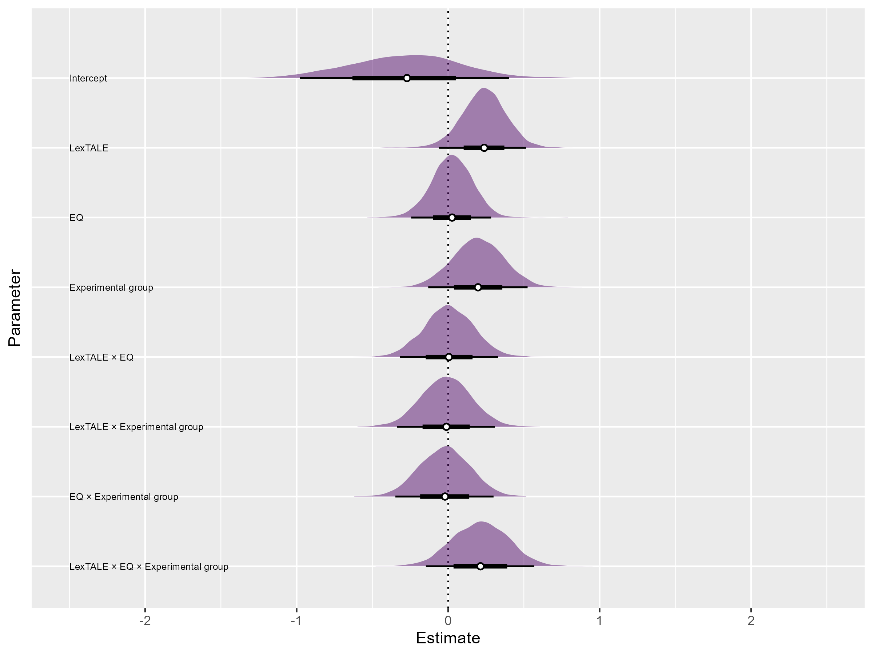

Figure 4. Forest plot summary of second model, which includes only Caribbean absolute interrogatives. White points represent posterior medians along with 66% and 95% highest density credible intervals.

Figure Figure 4 summarizes the posterior distribution of the response accuracy model, illustrating point estimates ±66% and 95% HDIs in graphical form. The log-odds of a correct response at the average proficiency and EQ levels in the control group was -0.27, or approximately 43.29%, (β = -0.27, HDI = [-0.98, 0.40], ROPE = 0.19, MPE = 0.79). The experimental group had a slightly higher median estimate, but it should be noted that the HDI distribution is very large ((β = −0.08, HDI = [−0.87, 0.70], ROPE = 0.20, MPE = 0.57)). This is to say, group by itself is not an adequate predictor of response accuracy.

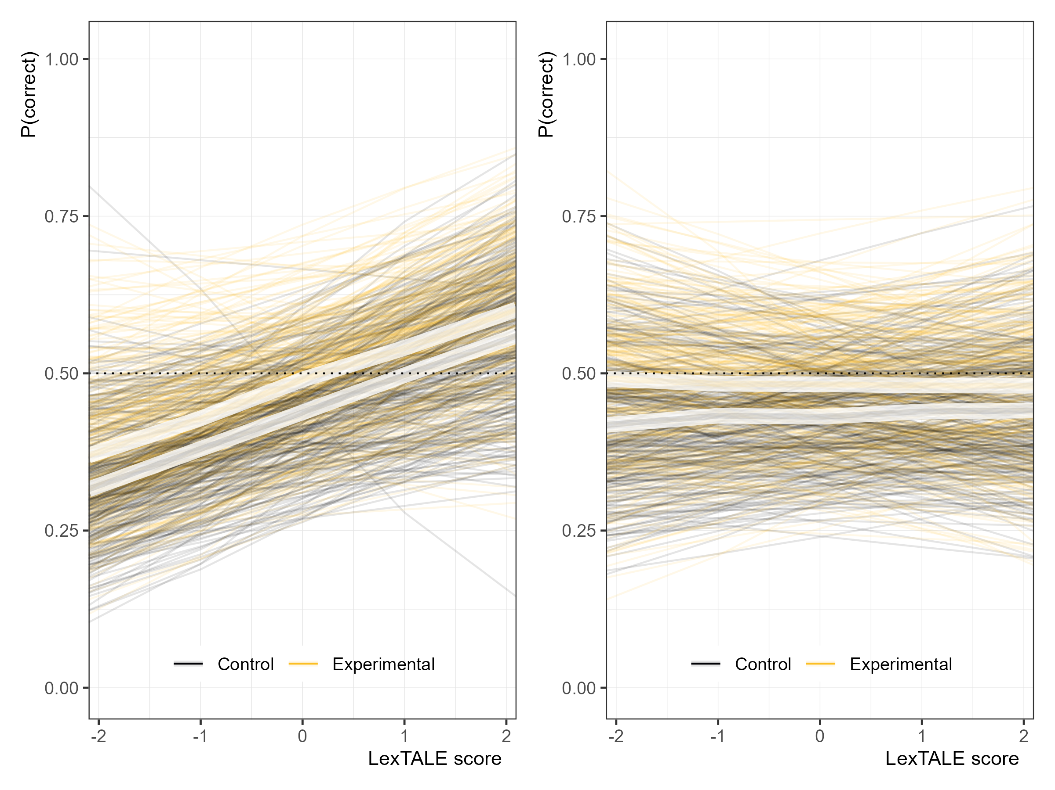

Figure 5. Conditional effects of a correct response as a function of proficiency (LexTALE score; left panel) and empathy quotient (right panel) for each combination of sentence type and Spanish variety. Thin lines represent 300 draws from the posterior distribution for each condition and illustrate uncertainty (95% HDI) around the posterior medians (thick lines).

Figure 5 illustrates the relationship between response accuracy (left panel) and EQ (right panel) with response accuracy. The effect of proficiency in both groups was similarly positive (control: (β = 0.24, HDI = [−0.06, 0.51], ROPE = 0.15, MPE = 0.95); experimental: (β = 0.23, HDI = [−0.09, 0.50], ROPE = 0.17, MPE = 0.94)), and the effect was practically equivalent between the two groups ((β = -0.01, HDI = [-0.34, 0.31], ROPE = 0.48, MPE = 0.53)). There was no evidence that empathy alone had an effect on response accuracy in either group (control: (β = 0.03, HDI = [−0.24, 0.28], ROPE = 0.57, MPE = 0.58); experimental: (β = 0.00, HDI = [−0.28, 0.29], ROPE = 0.54, MPE = 0.51)).

Although no effect was found for empathy alone, an interaction effect between empathy and proficiency was found in only the experimental group. The relationship is plotted in Figure 6. In the left panel, response accuracy remains constant at standardized EQ values of -1, 0, and +1 across different proficiency levels in the control group ((β = 0.00, HDI = [−0.32, 0.33], ROPE = 0.48, MPE = 0.51)). In the experimental group, on the other hand, the slope of the proficiency effect increases for higher EQ values ((β = 0.22, HDI = [−0.09, 0.52], ROPE = 0.20, MPE = 0.93)). It should be noted that the effect here is weak, as indicated by the HDI including 0 and the given ROPE value. However, the bulk of the posterior is positive, and the MPE value close to 1 indicates higher certainty in the effect’s direction. In other words, learners with high empathy (black lines) with above average proficiency tended to respond more accurately to Caribbean absolute interrogatives than their proficiency-matched peers only in the experimental group.

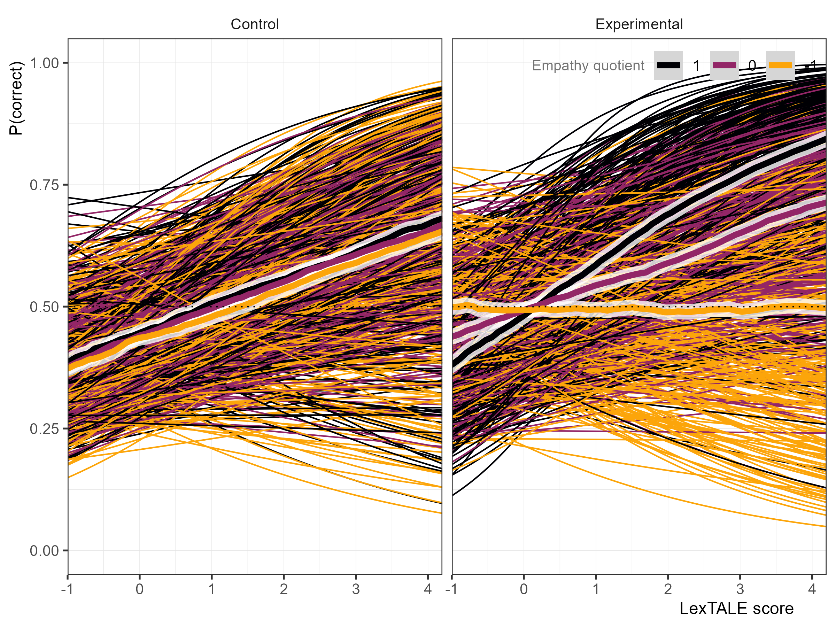

Figure 6. Probability of a correct response as a function of LexTALE score while holding empathy quotient scores constant at -1, 0, and +1 standard deviations from the mean. Thin lines represent 300 draws from the posterior distribution and indicate uncertainty (95% HDI) around the posterior medians (thick lines).

To illustrate the interaction of empathy and proficiency, I compared predicted accuracy for learners at low (-1 SD) versus high (+1 SD) empathy across two levels of proficiency (+1 SD and +2 SD). At 1 SD above mean proficiency, learners with higher empathy were approximately 10.41 percentage points (HDI = [-11.05, 31.23]) more accurate than those with low empathy, which corresponds to a 21.79% relative increase in accuracy (HDI = [-26.66, 85.03]). At 2 SD above mean proficiency, learners with higher empathy were approximately 19.66 percentage points (HDI = [-11.30, 51.05]) more accurate than those with low empathy, which corresponds to a 40.48% relative increase in accuracy (HDI = [-33.23, 165.91]).

# 5. Discussion

## 

## *5.1 RQ1*

The first research question, *Do higher-empathy L1 English L2 Spanish speakers make greater use of prosodic cues to determine if a Spanish utterance is an interrogative?*, was a partial replication of Casillas et al. (2023). I found that empathy did modulate response accuracy, specifically for non-Caribbean utterances. Caribbean utterances, on the other hand, did not show an effect for empathy. These findings do not directly contradict Casillas et al. (2023), but they are slightly different. Where Casillas et al. (2023) found a relationship between accuracy and empathy for declaratives, they did not find such for absolute interrogatives. This relationship was expected by them based on previous research on empathy and absolute interrogatives in L1 Salerno Italian speakers (Orrico & D’imperio, 2020).

Proficiency, as measured by the LexTALE-ESP (Izura et al., 2014; Lemhöfer & Broersma, 2012), was taken into consideration in this cross-sectional design. Surprisingly, proficiency was not found to have an effect on non-Caribbean declaratives, and in fact showed negative trends for non-Caribbean absolute interrogatives and Caribbean declaratives. Caribbean absolute interrogatives, on the other hand, showed a positive relationship with proficiency. The general findings on proficiency directly contradict previous research on the relationship between L2 intonation development and target language proficiency (Brandl et al., 2020; Casillas et al., 2023; Nibert, 2006; Trimble, 2013a). The validity of the LexTALE as a proxy measure of global proficiency has been questioned (Puig-Mayenco et al., 2023). However, these findings remain surprising, as Casillas et al. (2023) utilized the same measure of proficiency.

An interaction between empathy and proficiency was observed only for non-Caribbean absolute interrogatives: individuals with higher empathy were “protected” from the negative-going proficiency trend, such that high-empathy individuals responded more accurately than their lower-empathy proficiency-matched peers. Although an interaction effect was also found by Casillas et al. (2023), the trend was particularly different: they found that empathy had a “compounding effect” on the relationship between response accuracy and proficiency, such that lower-proficiency individuals with higher empathy showed more accuracy than their proficiency-matched peers only in wh- questions.

One reason that empathy predicted response accuracy only for non-Caribbean utterances may be due to lack of exposure to Caribbean varieties, which are not typically featured in classrooms (Gallego & Conley, 2013). This hypothesis is supported by Orrico and D’imperio (2020). They investigated L1 Salerno Italian speakers processing Italian sentences with varying nuclear configurations to predict degree of perceived positive bias (i.e., expected positive answer). They found that high-empathy listeners were more affected by degree of non-native dialect exposure. The second research question targets this exposure effect.

## 

## *5.2 RQ2*

Although Casillas et al. (2023) found a relationship between empathy and response accuracy, it remained unclear why such a relationship existed. The second research question, *Do higher-empathy L1 English L2 Spanish speakers make greater use of prosodic input from dialects to which they have little or no exposure to extract prosodic features?*, aimed to provide greater understanding of the cognitive relationship between empathy and intonation processing.

Previous work shows that higher-empathy indviduals retain more detail from social interactions (Melchers et al., 2017), and that both empathy and dialect exposure can shape phonological processing in L1 populations (Orrico & D’imperio, 2020). Building on this, the current study aimed to determine if higher-empathy L1 English L2 Spanish learners benefited greater from exposure to a novel intonation-meaning mapping, specifically Spanish absolute interrogatives with a final fall, when later determining if an utterance is an interrogative or not.

No effect was found for empathy alone, but there was evidence for a weak interaction between empathy and proficiency only for trained individuals. Specifically, individuals at the average proficiency level did not benefit from higher empathy, but individuals with higher empathy and above-average proficiency outperformed on average their peers. These results corroborate the idea that higher empathy individuals retain more detail from social interactions (Melchers et al., 2017), but in L2 processing, empathy specifically works to modulate a proficiency effect. Participants must have a certain proficiency in a language, as well as higher empathy, to benefit from rapid, incidental exposure to an unfamiliar intonation-to-meaning mapping.

Within the language classroom, these findings suggest that only a small set of students (those with both higher empathy and higher proficiency) will benefit from brief incidental intonation exposure. It is clear that exposure alone is not sufficient for all individuals to acquire target intonation in production (Herrero et al., 2020) or perception (Herrero & Devı́s, 2020), and it is also clear that intentional learning (Olea, 2019; Sonsaat-Hegelheimer & Levis, 2025) reaps wider benefits than those found in the present study. As such, the results of this study point towards a greater need of more intentional-learning training for intonation.

## 

## *5.3 Limitations and Future Directions*

While the current study provides evidence that higher-empathy, higher-proficiency L2 learners benefit from incidental learning of a novel intonation-meaning mapping than their lower-empathy peers, a longitudinal study would be required to know if these gains are maintained or if their lower-empathy peers “catch up” with repeated exposure.

Secondly, the negative proficiency effect was particularly surprising. It appears unlikely that the LexTALE-ESP (Izura et al., 2014; Lemhöfer & Broersma, 2012), the measure of proficiency used in this study, is inadequately correlated with L2 intonational development, at least when it comes to identifying these sentence types as an interrogative or not, as Casillas et al. (2023) found a positive effect for proficiency, also measured with the LexTALE-ESP, across the board. It is possible that the greater balance between high and low boundary tones signaling absolute interrogatives in this study, as opposed to Casillas et al. (2023), may have created competing sound-to-meaning relationships that were not accurately resolved by the current participants.

Lastly, current research relating empathy to phonology has focused primarily on suprasegmental features. Although more suprasegmental research is much needed, investigations exploring the relationship between empathy and segmentals is also needed to determine how pervasive the effect of empathy is on L2 phonological development.

# 6. Conclusion

The current study investigated the impact that incidental learning and empathy has on the acquisition of a novel intonation-meaning mapping. I found that individuals with above-average empathy and proficiency were more sensitive to the novel mapping after brief exposure to naturalistic conversation compared to their lower-empathy peers, and also compared to those who did not have the exposure. This study contributes to our understanding of how individual differences impact L2 learner intonation outcomes, as well as providing evidence that incidental learning of intonation may only be beneficial for a small subset of L2 learners. These results encourage more research in pragmatic skill as it relates to L2 learner outcomes, and how these findings, and those of Casillas et al. (2023), relate to findings from L1 research on empathy and language processing.

# 7. References

Armstrong, M. E. (2010). Puerto rican spanish intonation. *Transcription of Intonation of the Spanish Language*, 155–189. <https://doi.org/10.21437/speechprosody.2010-145>

Astruc, L., Mora, E., & Rew, S. (2010). Venezuelan andean spanish intonation. *Transcription of Intonation of the Spanish Language*, 191–226. <https://doi.org/10.3765/exabs.v0i0.582>

Bailey, A. A. (2014). Intonational phonology of cuban spanish: A preliminary model. *Proc. SpeechProsody 2014*, 809–813. <https://doi.org/10.21437/speechprosody.2014-151>

Baron-Cohen, S. (2011). *Zero degrees of empathy: A new theory of human cruelty* (Vol. 30). Penguin uk. <https://doi.org/10.1192/bjp.bp.111.098434>

Baron-Cohen, S., & Wheelwright, S. (2004). The empathy quotient: An investigation of adults with asperger syndrome or high functioning autism, and normal sex differences. *Journal of Autism and Developmental Disorders*, *34*, 163–175. <https://doi.org/10.1023/b:jadd.0000022607.19833.00>

Bedialauneta Txurruka, I. (2023). Perception of spanish declarative questions and statements by L2 spanish speakers. In R. Skarnitzl & J. Vol’ın (Eds.), *Proceedings of the 20th international congress of phonetic sciences* (pp. 2591–2596). Guarant International. <https://doi.org/10.1017/S0025100323000348>

Bishop, J. (2016). Individual differences in top-down and bottom-up prominence perception. *Proceedings of Speech Prosody*, *2016*, 668–672. <https://doi.org/10.21437/speechprosody.2016-137>

Bishop, J. B., Chong, A. J., & Jun, S.-A. (2015). Individual differences in prosodic strategies to sentence parsing. *ICPhS*. <https://doi.org/10.1177/0023830914563368>

Brandl, A., Gonz’alez, C., & Bustin, A. (2020). The development of intonation in L2 spanish: A perceptual study. In *Hispanic linguistics* (pp. 11–32). John Benjamins Publishing Company. <https://doi.org/10.1075/ihll.26.01bra>

Büring, D. (2016). *Intonation and meaning*. Oxford University Press. <https://doi.org/10.1093/acprof:oso/9780199226269.001.0001>

Bürkner, P.-C. (2017a). Advanced bayesian multilevel modeling with the r package brms. *arXiv Preprint arXiv:1705.11123*. <https://doi.org/10.32614/rj-2018-017>

Bürkner, P.-C. (2017b). Brms: An r package for bayesian multilevel models using stan. *Journal of Statistical Software*, *80*, 1–28. <https://doi.org/10.18637/jss.v080.i01>

Carruthers, P. (2009). Mindreading underlies metacognition. *Behavioral and Brain Sciences*, *32*(2), 164–182. <https://doi.org/10.1017/s0140525x09000831>

Casillas, J. V., Garrido-Poz’u, J. J., Parrish, K., Arroyo, L. F., Rodr’ıguez, N., Esposito, R., Chang, I., G’omez, K., Constantin-Dureci, G., Shao, J., et al. (2023). Using intonation to disambiguate meaning: The role of empathy and proficiency in L2 perceptual development. *Applied Psycholinguistics*, *44*(5), 913–940. <https://doi.org/10.1017/S0142716423000310>

Dev’ıs Herraiz, E., & Cantero Serena, F. J. (2014). The intonation of mitigating politeness in catalan. *Journal of Politeness Research*, *10*(1), 127–149. <https://doi.org/10.1515/pr-2014-0006>

Diehl, J. J., Bennetto, L., Watson, D., Gunlogson, C., & McDonough, J. (2008). Resolving ambiguity: A psycholinguistic approach to understanding prosody processing in high-functioning autism. *Brain and Language*, *106*(2), 144–152. <https://doi.org/10.1016/j.bandl.2008.04.002>

Estebas-Vilaplana, E. (2014). The evaluation of intonation: Pitch range differences in english and in spanish. In *Evaluation in context* (pp. 179–194). John Benjamins Publishing Company. <https://doi.org/10.1075/pbns.242.09est>

Esteve-Gibert, N., Portes, C., Schafer, A., Hemforth, B., & D’Imperio, M. (2016). The role of individual empathic skills on the online processing of intonational meaning. *Architectures and Mechanisms for Language Processing (AMLaP)*. <https://doi.org/10.21437/speechprosody.2016-252>

Esteve-Gibert, N., Schafer, A. J., Hemforth, B., Portes, C., Pozniak, C., & D’Imperio, M. (2020). Empathy influences how listeners interpret intonation and meaning when words are ambiguous. *Memory & Cognition*, *48*, 566–580. <https://doi.org/10.3758/s13421-019-00990-w>

Face, T. L. (2007). The role of intonational cues in the perception of declaratives and absolute interrogatives in castilian spanish. *Journal of Experimental Phonetics*, *16*, 185–225. <https://doi.org/10.1515/shll-2012-1125>

Flege, J. E., & Bohn, O.-S. (2021). The revised speech learning model (SLM-r). In R. Wayland (Ed.), *Second language speech learning: Theoretical and empirical progress* (pp. 3–83). Cambridge University Press. <https://doi.org/10.1017/9781108886901.002>

Frith, U., & Frith, C. D. (2003). Development and neurophysiology of mentalizing. *Philosophical Transactions of the Royal Society of London. Series B: Biological Sciences*, *358*(1431), 459–473. <https://doi.org/10.1098/rstb.2002.1218>

Gabriel, C., Feldhausen, I., Peškov’a, A., Colantoni, L., Lee, S.-A., Arana, V., & Labast’ıa, L. (2010). Argentinian spanish intonation. *Transcription of Intonation of the Spanish Language*, 285–317. <https://doi.org/10.1353/hpn.2010.a382873>

Gallego, M., & Conley, R. (2013). Raising dialectal awareness in spanish as a foreign language courses. *CAUCERevista Internacional de Filologı́a, Comunicación y Sus Didácticas*, 36–37. <https://doi.org/10.1007/978-3-031-27829-7_5>

Gelman, A., Simpson, D., & Betancourt, M. (2017). The prior can often only be understood in the context of the likelihood. *Entropy*, *19*(10), 555. <https://doi.org/10.3390/e19100555>

George, A. (2019). Teaching and learning L2 spanish intonation: Technology and classroom instruction. *Conference Proceedings. Innovation in Language Learning 2019*. <https://doi.org/10.5070/l29335670>

George, A. (2024). L2 intonation perception in learners of spanish. *Perspectives on Input, Evidence, and Exposure in Language Acquisition: Studies in Honour of Susanne E. Carroll*, *69*, 144. <https://doi.org/10.1075/lald.69.06geo>

Herrero, C., & Dev’ıs, E. (2020). Unintentional impolite intonation in L2 spanish requests produced by chinese workers living in madrid. *Proceedings of the 10th International Conference on Speech Prosody*, 848–852. <https://doi.org/10.21437/speechprosody.2020-173>

Herrero, C., Planelles, M., & Alhmoud, Z. (2020). Perception of L2 spanish polite requests and impolite commands by chinese migrant workers living in spain. *Lengua y Migración*, *12*(2), 65–85. <https://doi.org/10.37536/lym.12.2.2020.1026>

Hulstijn, J. H. (2003). Incidental and intentional learning. *The Handbook of Second Language Acquisition*, 349–381. <https://doi.org/10.1002/9780470756492.ch12>

Izura, C., Cuetos, F., & Brysbaert, M. (2014). Lexical test for advanced learners of spanish. *Psicológica*. <https://doi.org/10.1037/t47086-000>

Jenkins, J. (2004). 5. Research in teaching pronunciation and intonation. *Annual Review of Applied Linguistics*, *24*, 109–125. <https://doi.org/10.1017/s0267190504000054>

Kabak, B. (2016). Refin (d) ing turkish stress as a multifaceted phenomenon. *Paper Delivered at Second Conference on Central Asian Languages and Linguistics (ConCALL-2)*. <https://doi.org/10.1017/s0952675701004201>

Kruschke, J. K. (2018). Rejecting or accepting parameter values in bayesian estimation. *Advances in Methods and Practices in Psychological Science*, *1*(2), 270–280. <https://doi.org/10.31219/osf.io/s5vdy>

Ladd, D. R. (2008). *Intonational phonology*. Cambridge University Press. <https://doi.org/10.1017/cbo9780511808814>

Lemhöfer, K., & Broersma, M. (2012). Introducing LexTALE: A quick and valid lexical test for advanced learners of english. *Behavior Research Methods*, *44*(2), 325–343. <https://doi.org/10.3758/s13428-011-0146-0>

Melchers, M., Montag, C., Markett, S., Niazy, N., Groß-Bölting, J., Zimmermann, J., & Reuter, M. (2017). The OXTR gene, implicit learning and social processing: Does empathy evolve from perceptual skills for details? *Behavioural Brain Research*, *329*, 35–40. <https://doi.org/10.1016/j.bbr.2017.04.036>

Mennen, I. (2015). Beyond segments: Towards a L2 intonation learning theory. In *Prosody and language in contact: L2 acquisition, attrition and languages in multilingual situations* (pp. 171–188). Springer. <https://doi.org/10.1007/978-3-662-45168-7>

Navarro Tom’as, T. et al. (1974). *Manual de entonación española*. Biblioteca Hernán Malo González. <https://doi.org/10.1007/springerreference_76175>

Nibert, H. J. (2006). The acquisition of the phrase accent by beginning adult learners of spanish as a second language. *Selected Proceedings of the 2nd Conference on Laboratory Approaches to Spanish Phonetics and Phonology*, 131–148. <https://doi.org/10.1075/lald.4.09pla>

Olea, M. S. A. U. (2019). The effectiveness of the instruction of the intonation of english implications to L1 spanish trainee teachers. *Logos: Revista de Lingüı́stica, Filosofı́a y Literatura*, *29*(2), 399–414. <https://doi.org/10.15443/rl2930>

Orrico, R., & D’imperio, M. (2020). Individual empathy levels affect gradual intonation-meaning mapping: The case of biased questions in salerno italian. *Laboratory Phonology: Journal of the Association for Laboratory Phonology*, *11*(1), 1–39. <https://doi.org/10.5334/labphon.238>

Orrico, R., D’Imperio, M., et al. (2020). Tonal specification of speaker commitment in salerno italian wh-questions. *Speech Prosody*, 361–365. <https://doi.org/10.21437/SpeechProsody.2020-74>

Orrico, R., Gryllia, S., Kim, J., & Arvaniti, A. (2025). Individual variability and the h*~ l+ h* contrast in english. *Language and Cognition*, *17*, e9. <https://doi.org/10.1017/langcog.2024.62>

Ortega-Llebaria, M., & Colantoni, L. (2014). L2 english intonation: Relations between form-meaning associations, access to meaning, and L1 transfer. *Studies in Second Language Acquisition*, *36*(2), 331–353. <https://doi.org/10.1017/s0272263114000011>

P’erez Castillejo, S., & de la Fuente Iglesias, M. (2024). Basic intonation patterns of galician spanish. *Languages*, *9*(2), 57. <https://doi.org/10.3390/languages9020057>

Peirce, J., Gray, J. R., Simpson, S., MacAskill, M., Höchenberger, R., Sogo, H., Kastman, E., & Lindeløv, J. K. (2019). PsychoPy2: Experiments in behavior made easy. *Behavior Research Methods*, *51*(1), 195–203. <https://doi.org/10.3758/s13428-018-01193-y>

Pierrehumbert, J. B. (1980). *The phonology and phonetics of english intonation* [PhD thesis, Massachusetts Institute of Technology]. <https://doi.org/10.3726/978-3-653-04390-7/7>

Prieto, P., & Roseano, P. (2009--2013). *Atlas interactivo de la entonación del español*. <http://prosodia.upf.edu/atlasentonacion/>. <https://doi.org/10.31390/gradschool_theses.4679>

Prieto, P., & Roseano, P. (2010). *Transcription of intonation of the spanish language*. Lincom Europa Munich. <https://doi.org/10.1075/sic.10.2.08fac>

Puig-Mayenco, E., Chaouch-Orozco, A., Liu, H., & Mart’ın-Villena, F. (2023). The LexTALE as a measure of L2 global proficiency: A cautionary tale based on a partial replication of lemhöfer and broersma (2012). *Linguistic Approaches to Bilingualism*, *13*(3), 299–314. <https://doi.org/10.1075/lab.22048.pui>

Rao, R. (2019). *Key issues in the teaching of spanish pronunciation*. Routledge London, United Kingdom. <https://doi.org/10.4324/9781315666839>

Rodero, E. (2011). Intonation and emotion: Influence of pitch levels and contour type on creating emotions. *Journal of Voice*, *25*(1), e25–e34. <https://doi.org/10.1016/j.jvoice.2010.02.002>

Sonsaat-Hegelheimer, S., & Levis, J. (2025). Is intonation learnable in the classroom? Evidence from turkish learners of english. *Language Teaching Research*, 13621688241312502. <https://doi.org/10.2139/ssrn.4710794>

Trimble, J. C. (2013a). *Acquiring variable L2 spanish intonation in a study abroad context* [PhD thesis, University of Minnesota]. <https://doi.org/10.1075/ihll.37.04tri>

Trimble, J. C. (2013b). Perceiving intonational cues in a foreign language: Perception of sentence type in two dialects of spanish. *Selected Proceedings of the 15th Hispanic Linguistics Symposium*, 78–92. <https://doi.org/10.1016/s0095-4470(19)31304-x>

Trofimovich, P., & Baker, W. (2006). Learning second language suprasegmentals: Effect of L2 experience on prosody and fluency characteristics of L2 speech. *Studies in Second Language Acquisition*, *28*(1), 1–30. <https://doi.org/10.1515/iral.2011.007>

Ward, G., & Hirschberg, J. (1988). Intonation and propositional attitude: The pragmatics of l*+ HLH%. *Proceedings of the Fifth Eastern States Conference on Linguistics*, 512–522. <https://doi.org/10.1163/9780585474472>

Willis, E. (2010). Dominican spanish intonation. *Transcription of Intonation of the Spanish Language*, 123–153. <https://doi.org/10.4324/9781003054979-4>